THE BATTLE OF LAMBSTOWN, 1650
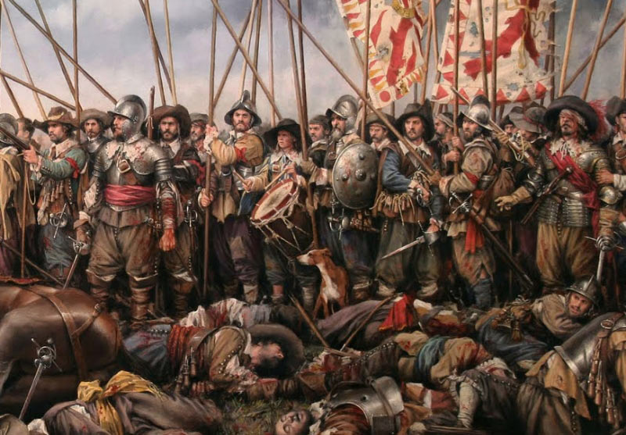
On the 5th of October 1650 a bloody battle was fought near the border of Bree and Glynn parishes at place called Lambstown. It saw a small Irish Confederate force take on Oliver Cromwell’s new model army in a violent struggle that would leave many dead and wounded.
The seeds of the battle had been sown a year earlier when Cromwell’s army marched through Bree on its way to Wexford town, camping for a night in Garranstackle townland (Shield 1920, p. 117). Although Wexford was subsequently captured and many of its citizens massacred, Bree and the surrounding parishes were not subdued.
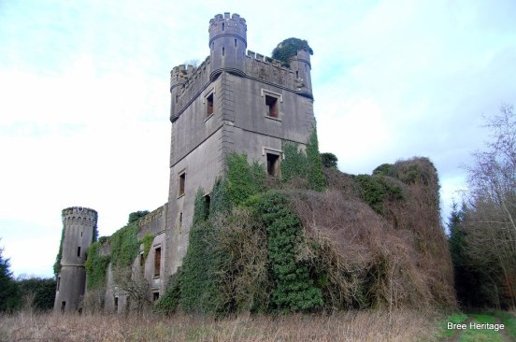Macmine castle, home of Nicholas Fitzhenry
A group of rebel fighters remained in the vicinity, under the command of Nicholas Fitzhenry of Macmine castle, Bree. On the 5th of October Nicholas’ men joined forces with a small Confederate army, led by Piers Butler of Duiske and together they marched to meet Cromwell’s battle hardened garrison from Wexford town.
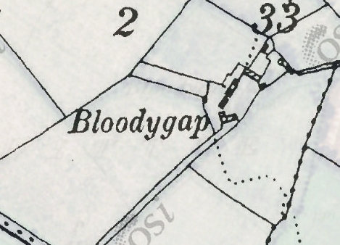The site of the battle, ‘Bloody gap’ on the 1st edition O.S. map of c. 1839
From the start, the encounter did not go well for the Irish and at a spot later referred to as ‘Bloody Gap’, they were decisively defeated (this location is recorded on the Ordnance Survey Map of c. 1839, see above). Reputedly the carnage was so great that the surrounding ditches ran red with blood for two days afterwards (Griffiths 1877, p. 134).
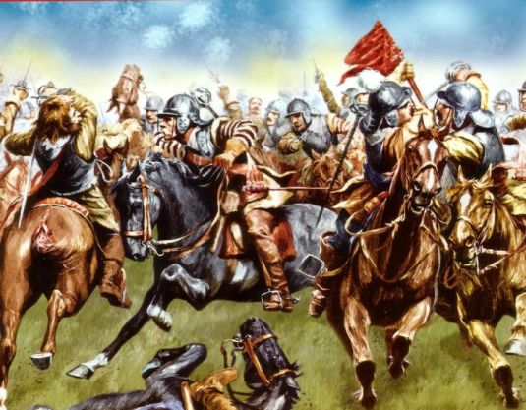17th century battle scene
Nicholas Fitzhenry distinguished himself during the battle and his men caused much confusion and destruction in the Cromwellian ranks (ibid). However, it was all in vain and by the end of the fighting the Irish force was destroyed.
Their leader, Piers Butler, was captured and summarily executed, while three of Nicholas’ brothers lay dead dead on the battle field. Although he escaped the fighting, Nicholas was a marked man and had to flee to France, abandoning Macmine castle and thus ending over 400 years of Fitzhenry rule in Bree parish.
Notes
1. Oliver Cromwell was not personally involved in the Battle of Lamstown having left for England in May 1650 . His army in Ireland was left under the command of his son in law, Henry Ireton.
2. Other commanders in the Irish army at Lambstown included Thomas Esmonde of Ballynastragh, Christopher Hore of Polehore, Philip Hore of Kilshavan and an unnamed Furlong who commanded a force from Glynn.
References
Griffiths, G. 1877. Chronicles of the County Wexford. Enniscorthy, pp. 133-4
Hore, H. F. (1862) ‘An Account of the Barony of Forth, in the County of Wexford, Written at the Close of the Seventeenth Century’ in The Journal of the Kilkenny and South-East of Ireland Archaeological Society, New Series, Vol. 4, No. 1 (1862), pp. 53-84
Shield, P. (1921) ‘The Parish of Bree’ in The Past: The Organ of the Uí Cinsealaigh Historical Society, No. 2 (Dec, 1921), pp. 113-119

